Windows support
Before deploying Windows nodes, be aware of the following considerations.
Considerations
- Amazon EC2 instance types C3, C4, D2, I2, M4 (excluding m4.16xlarge), M6a.x, and R3 instances are not supported for Windows workloads.
- Host networking mode is not supported for Windows workloads.
- Amazon EKS clusters must contain one or more Linux or Fargate nodes to run core system pods that only run on Linux, such as CoreDNS.
- The kubelet and kube-proxy event logs are redirected to the EKS Windows Event Log and are set to a 200 MB limit.
- You can't use Security groups for pods with pods running on Windows nodes.
- You can't use custom networking with Windows nodes.
- You can't use IP prefixes with Windows nodes. This is a requirement for using IPv6, so you can't use IPv6 with Windows nodes either.
- Windows nodes support one elastic network interface per node. The number of pods that you can run per Windows node is equal to the number of IP addresses available per elastic network interface for the node's instance type, minus one. For more information, see IP addresses per network interface per instance type in the Amazon EC2 User Guide for Windows Instances.
- In an Amazon EKS cluster, a single service with a load balancer can support up to 64 back-end pods. Each pod has its own unique IP address. This is a limitation of the Windows operating system on the Amazon EC2 nodes.
- You can't deploy Windows managed or Fargate nodes. You can only create self-managed Windows nodes. For more information, see Launching self-managed Windows nodes.
- You can't retrieve logs from the vpc-resource-controller Pod. You previously could when you deployed the controller to the data plane.
- There is a cool down period before an IPv4 address is assigned to a new Pod. This prevents traffic from flowing to an older Pod with the same IPv4 address due to stale kube-proxy rules.
- The source for the controller is managed on GitHub. To contribute to, or file issues against the controller, visit the project on GitHub.

Pre-requisites to deploy windows containers on EKS
- An existing cluster. The cluster must be running one of the Kubernetes versions and platform versions listed in the following table. Any Kubernetes and platform versions later than those listed are also supported. If your cluster or platform version is earlier than one of the following versions, you need to enable legacy Windows support on your cluster's data plane. Once your cluster is at one of the following Kubernetes and platform versions, or later, you can remove legacy Windows support and enable Windows support on your control plane.

Kubernetes version | Platform version
1.21 | eks.3
1.20 | eks.3
1.19 | eks.7
1.18 | eks.9
1.17 | eks.10
- Your cluster must have at least one (we recommend at least two) Linux node or Fargate pod to run CoreDNS. If you enable legacy Windows support, you must use a Linux node (you can't use a Fargate pod) to run CoreDNS

- Existing Cluster IAM Role: -

The IAM security principal that you're using must have permissions to work with Amazon EKS IAM roles and service linked roles, AWS CloudFormation, and a VPC and related resources. For more information, see Actions, resources, and condition keys for Amazon Elastic Container Service for Kubernetes and Using service-linked roles in the IAM User Guide. You must complete all steps in this guide as the same user.

https://docs.aws.amazon.com/eks/latest/userguide/service_IAM_role.html

- CLIs: -
- AWS CLI (https://docs.aws.amazon.com/cli/latest/userguide/getting-started-install.html)
- Kubectl (https://docs.aws.amazon.com/eks/latest/userguide/install-kubectl.html)

- Eksctl (https://docs.aws.amazon.com/eks/latest/userguide/eksctl.html)

Install EKS cluster using eksctl
- Create EKS cluster using below eksctl command
eksctl create cluster --name <cluster-name> --region <region-code> --zones <zone-codes> --without-nodegroup
- To verify cluster eksctl get clusters
- To enable and use AWS IAM roles for kubernetes servic accounts on EKS cluster, Create and Associate IAM OIDC Provider for our EKS Cluster
eksctl utils associate-iam-oidc-provider \
--region <region-code> \
--cluster <cluster-name> \
--approve
- Create EC2 Keypair to connect worker nodes. This is required to connect node ec2 instances.

- Create Linux node group (get add on help using eksctl create nodegroup --help)
eksctl create nodegroup \
--cluster=<cluster-name> \
--region=<region-code> \
--name=<nodegroup-name> \
--node-type=<specify ec2-instance-type> \
--nodes=2 \
--nodes-min=1 \
--nodes-max=3 \
--node-volume-size=<specify volume size> \
--ssh-access \
--ssh-public-key=<specify SSH key> \
--managed \
--asg-access \
--external-dns-access \
--full-ecr-access \
--appmesh-access \
--appmesh-preview-access \
--alb-ingress-access

- Verify nodes
kubectl get nodes
kubectl get nodes -o wide

Now we can deploy our linux containers on eks cluster.

Windows node on eks cluster

- Create eksClusterRole IAM role (This can be skipped if we already have an existing cluster IAM role)
To create your Amazon EKS cluster role in the IAM console
- Open the IAM console at https://console.aws.amazon.com/iam/.
- Choose Roles, then Create role.
- Under Use case, choose EKS from the list of services under Use cases for other AWS services.
- Choose EKS - Cluster for your use case, and then choose Next.
- On the Add permissions tab, choose Next.
- For Role name, enter a unique name for your role, such as eksClusterRole.
- For Description, enter descriptive text such as Amazon EKS - Cluster role.
- Choose Create role.

- Attach the AmazonEKSVPCResourceController managed policy to your Amazon EKS cluster IAM role. Replace eksClusterRole with your cluster role name.
aws iam attach-role-policy \
--role-name eksClusterRole \
--policy-arn arn:aws:iam::aws:policy/AmazonEKSVPCResourceController

To check cluster role
aws iam list-attached-role-policies --role-name eksClusterRole
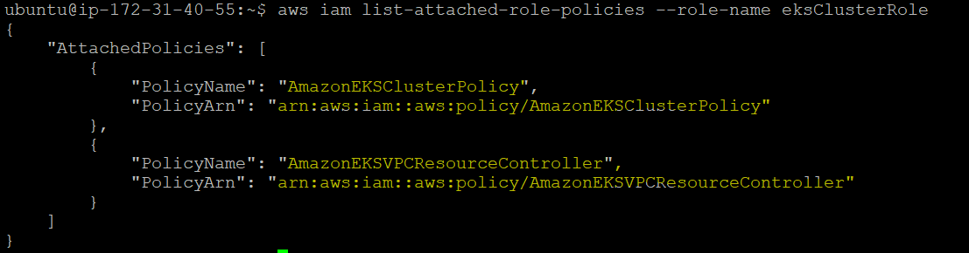

- Create a file named vpc-resource-controller-configmap.yaml with the following contents.

apiVersion: v1
kind: ConfigMap
metadata:
name: amazon-vpc-cni
namespace: kube-system
data:
enable-windows-ipam: "true"

- Apply the ConfigMap to your cluster

kubectl apply -f vpc-resource-controller-configmap.yaml

- Create windows nodes (Self managed)

eksctl create nodegroup \
--region=<region-code> \
--cluster=<cluster-name> \
--name=<nodegroup-name> \
--node-type=<specify ec2 instance type> \
--nodes=2 \
--nodes-min=1 \
--nodes-max=3 \
--node-ami-family=WindowsServer2019FullContainer \
--node-volume-size=<Specify volume size> \
--ssh-access \
--ssh-public-key=<specify SSH-Key> \
--managed=false \
--asg-access \
--external-dns-access \
--full-ecr-access \
--appmesh-access \
--appmesh-preview-access \
--alb-ingress-access

Now we can deploy windows containers on our cluster
When you deploy Pods to your cluster, you need to specify the operating system that they use if you're running a mixture of node types.
For Linux pods, use the following node selector text in your manifests.
nodeSelector:
kubernetes.io/os: linux
kubernetes.io/arch: amd64
For Windows pods, use the following node selector text in your manifests.
nodeSelector:
kubernetes.io/os: windows
kubernetes.io/arch: amd64

Reference Links
https://docs.aws.amazon.com/eks/latest/userguide/getting-started.html
https://docs.aws.amazon.com/eks/latest/userguide/windows-support.html
https://docs.aws.amazon.com/eks/latest/userguide/launch-windows-workers.html

